Title of Project:  
Underground Eco-Homes for Digital Nomads

Name:  
Jethin Babu Anuga Chitti

GitHub URL:  
https://github.com/jethin26/Database3.git

SQL environment:

Windows

**ERD Using UML:**

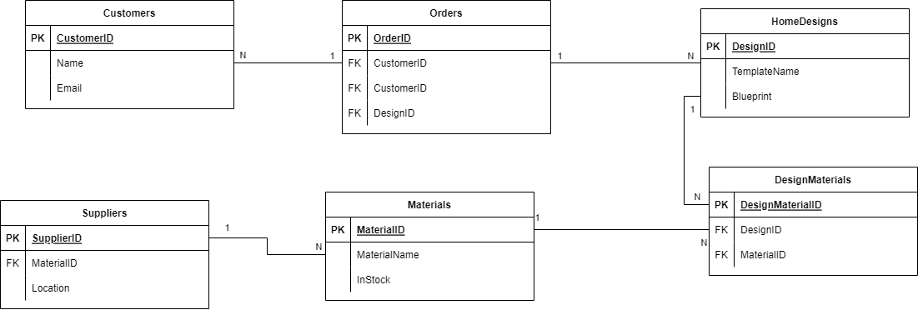

**ERD Using Crow Foot:**

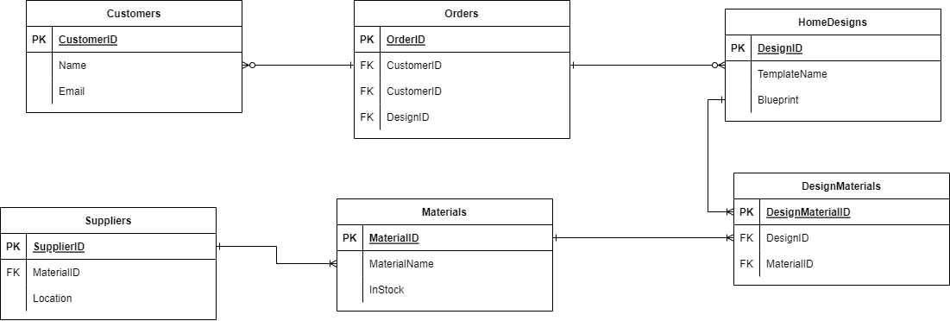

**Description of Relationships:**

1. **Relationship between Orders and Customers:**

Each Order is linked to exactly one Customer, and a Customer can have one or more Orders. This is a one-to-many relationship, represented as: An Order depends on 1 and only 1 Customer, and a Customer has 1 or more Orders.

1. **Relationship between Orders and HomeDesigns:**

Each Order is associated with exactly one HomeDesign, but a HomeDesign can be chosen for zero or more Orders. This is a many-to-one relationship, represented as: An Order depends on 1 and only 1 HomeDesign, while a HomeDesign is associated with 0 or more Orders.

1. **Relationship between HomeDesigns and DesignMaterials:**

A HomeDesign can require multiple different Materials (through DesignMaterials), and the same Material can be used in multiple HomeDesigns. This is a many-to-many relationship, simplified through the DesignMaterials associative entity, represented as: A HomeDesign is associated with 1 or more DesignMaterials entries, and each DesignMaterials entry links to 1 and only 1 HomeDesign.

1. **Relationship between Materials and DesignMaterials:**

The Material is used in one or more DesignMaterials entries, and each DesignMaterials entry specifies one and only one Material. This is a one-to-many relationship, represented as: A Material is associated with 1 or more DesignMaterials entries, while each DesignMaterials entry depends on 1 and only 1 Material.

1. **Relationship between Suppliers and Materials:**

A Supplier provides one or more Materials, but each Material comes from one and only one Supplier. This is a one-to-many relationship, represented as: A Supplier is associated with 1 or more Materials, and each Material depends on 1 and only 1 Supplier.